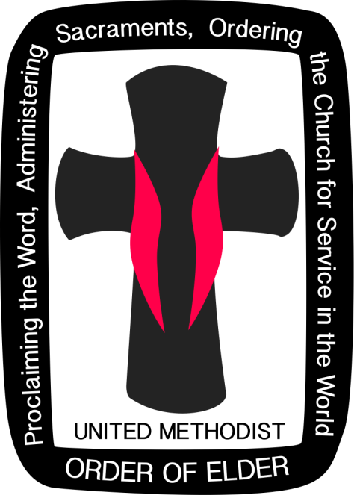 

Order of Elders & Deacons Retreat

April 1-3

2019

**Schedule of Events**

**Monday, April 1**

(Supper only on Monday)

1:00 pm Registration – Bagley Hall

3:00 pm Gathering – Bagley Hall

4:00 pm Worship – Bagley Hall

5:15 pm Supper

6:30 pm Session 1 – Bagley Hall

9:00 pm Ice Cream Fellowship

**Tuesday, April 2**

(Breakfast, Lunch, and Supper on Tuesday)

8:00 am Breakfast

9:00am Morning Prayer – Bagley Hall

9:30 am Session 2

12:15 pm Lunch

Sabbath Time, Study Time,

Play Time, Your Time

1:30 pm Workshop (*optional*): Bagley Hall

5:00 pm Supper

6:00 pm Reflecting on General Conference

8:00 pm Worship – Bagley Hall

9:00 pm Ice Cream Fellowship

**Wednesday, April 3**

(Breakfast only on Wednesday)

8:00 am Morning Prayer – Bagley Hall

8:30 am Breakfast (Brunch Style)

9:30 am Session 3

11:00 am Worship – Eucharist